THE TITLE OF YOUR THESIS SHOULD BE HERE ALL IN UPPERCASE LETTERS

MOJTABA

A thesis submitted in fulfilment of the

requirements for the award of degree of

PhD of Computer Science (Network Security)

Malaysia-Japan International Institute of Technology

Universiti Teknologi Malaysia

OCTOBER 2015

DECLARATION

I declare that this thesis entitled “*The Title of Your Thesis Should be Written Here*” is the result of my own research except as cited in the references. The thesis has not been accepted for any degree and is not concurrently submitted in candidature of any other degree.

Signature :

Name : MOJTABA

Date : October 2015

DEDICATION

**To my lovely mother,** who gave me endless love, trust, constant encouragement over the years, and for her prayers.

**To my Family,** for their patience, support, love, and for enduring the ups and downs during the completion of this thesis.

**This thesis is dedicated to them.**

ACKNOWLEDGEMENT

I wish to express my deepest appreciation to all those who helped me, in one way or another, to complete this project. First and foremost I thank God almighty who provided me with strength, direction and purpose throughout the project. Special thanks to my project supervisor Associate Professor Dr. ……. all her patience, guidance and support during the execution of this project. Through her expert guidance, I was able to overcome all the obstacles that I encountered in these enduring ten months of my project. In fact, she always gave me immense hope every time I consulted with her over problems relating to my project.

ABSTRACT

This document is prepared based on “**UTM Thesis Manual 2007**” by Mojtaba Alizadeh. A sample is provided for each style. There are few styles including Title, Heading, Paragraph, Table Caption, Figure Caption, and etc. The detail of each style is provided in this document. If you want to download this template, just go to [www.mojtabaalizadeh.com](http://www.mojtabaalizadeh.com) website, then go to “Research” tab, and click on “UTM Thesis Template”. To improve the quality of this template, please contact me if you find any formatting problem in this document. My email is **info@mojtabaalizadeh.com**

ABSTRAK

Abstract in “Bahasa Melayu” language should be written here.

TABLE OF CONTENTS

**CHAPTER TITLE PAGE**

DECLARATION ii

DEDICATION iii

ACKNOWLEDGEMENT iv

ABSTRACT v

ABSTRAK vi

TABLE OF CONTENTS vii

LIST OF TABLES ix

LIST OF FIGURES x

LIST OF ABBREVIATIONS xi

1. INTRODUCTION 1

1.1 Heading 1

1.2 Heading 1 1

1.2.1 Heading 2 1

1.2.1.1 Heading 3 1

1.3 Paragraph 2

1.4 Table 2

1.5 Figure 2

1.6 Bullet 3

1. OVERVIEW OF CLOUD COMPUTING 4
2. METHODOLOGY 5
3. RESULTS AND DISSCUSSIONS 6
4. CONCLUSION 7

REFRENCES 8

LIST OF TABLES

**TABLE NO. TITLE PAGE**

Table ‎1.1: Please keep in mind that the word “Table” and “Colon (:) character” should be deleted in “List of Tables” in the final version 2

LIST OF FIGURES

**FIGURE NO. TITLE PAGE**

Figure ‎1.1 Please keep in mind that the word “Figure” should be deleted in “List of Figures” in the final version 3

LIST OF ABBREVIATIONS

This part should be completed if you have used any abbreviations in your thesis.

# 

###### INTRODUCTION

## Research Background

Currently thermal spraying one of the new technology contains some of the most prominent ongoing development, innovation and progress in various fields of engineering to improve the surface property. Plasma spray is one of the most versatile of the thermal spray processes which material (feedstock) is introduced into a plasma jet causing the material melting and propelling to the surface to be coated. The process requiring a significant electrical power that can utilize plasma electrical generated to heat and melt the feedstock material with specialized of high temperature [1].

Coatings have become very important to enhance the performance of base materials used in industry such as land-based turbine engines for power generation, aerospace, and other that include paper, steel mills, chemical processing plants and oil industry, and, etc [2]. So, it necessary to understanding the fluid flow and heat transfer involved in plasma spray process for maintaining quality control for coating with desirable functionality [3].

Among other key features of plasma spraying are the formation of microstructures with fine, equiaxed and noncolumnar grains, the ability to process materials in virtually any environment (e.g., reduced-pressure inert gas, air, under water, high pressure) and the ability to produce homogeneous coatings that do not change in composition with thickness and length of deposition time [6]. W. Batchelor el (2003) said that applications for plasma spraying include erosion, corrosion, temperature and production of monolithic and near net shapes, which at the same time take advantage of the rapid solidification process. Powder of glassy metals can be plasma sprayed without changing their amorphous characteristics. High temperature superconductive materials have also been deposited by the plasma spray technique. [7].

## Statement of Problems

Currently numerous research works have been carried out to study the plasma spray processes because reproduction of coating quality is very difficult task to optimize the performance of the process. By trial and error, most of the time needed to optimize empirically because there are a lot of parameter that may influence the process of the coating and involvement of high cost equipment and measurement difficulties. To provide high-quality of products, it is necessary to develop a plasma spray with excellent performance with a stable plasma jet and long service life. Performance of the plasma spray depend on its cooling system. Numerical modelling and simulation of process help to understand the heat transfer mechanism and fluid flow of the cooling in a plasma spray, which is a very complicated process since there are no efficient ways to measure the temperature within the chamber. In order to assure long operating intervals and durability, it require an effective cooling concepts for these highly-loaded components.

## Objectives of the Study

The objectives of this research are as stated below:

i. To study the ideal design of cooling water

ii. To study the optimise cooling water for plasma spraying

iii. To study the heat transfer and fluid flow of plasma spray

iv. To study the formation of coating of plasma spray

## Scopes of the Study

The study will be focused on the:

i. Design cooling water system for the plasma spray reactor

ii. Simulate the cooling water using ANSYS Software

## Table

For Table title, Cross-reference and Table Caption is used. To write Table caption, just go to “References” tab and click “Insert Caption”, then select “Table” from “Label” box. To cite the Table in text like “Table ‎1.1”, just go to “References” tab and click “Cross-reference”, select “Table” in “Reference Type” box, and “only label and number” in “Insert Reference to” box, then select the Table that you want to cite.

Table .: Please keep in mind that the word “Table” and “Colon (:) character” should be deleted in “List of Tables” in the final version

|  |  |  |
| --- | --- | --- |
|  | **Cluster Computing** | **Grid Computing** |
| Type of Network | Systems are coupled tightly and operates like a Single system and job scheduling is centralized | Systems are coupled loosely and job scheduling is distributed |
| Location of Servers | All the computers are normally in a single physical location | The nodes are distributed over WAN, LAN, and MAN |

## Figure

For Figure title, Cross-reference and Figure Caption is used. To write Table caption, just go to “References” tab and click “Insert Caption”, then select “Figure” from “Label” box. To cite the Figure in text like “Figure ‎1.1”, just go to “References” tab and click “Cross-reference”, select “Figure” in “Reference Type” box, and “only label and number” in “Insert Reference to” box, then select the Figure that you want to cite.



Figure . Please keep in mind that the word “Figure” should be deleted in “List of Figures” in the final version

## Bullet

1. It is recommended to use this style for bullets.

###### literature review

## Introduction

This chapter discusses on the literature topic involved in the conduct of this research. This chapter provides better understanding about the process of plasma spraying and parameters involved in the research. The main subtopics of this research are water cooling system, computational fluid dynamic CFD, simulation assumptions, turbulence flow, swirl, and turbulence velocity

## Plasma Spraying Process

Typically, argon or gases mixtures are ionized and dissociated by a high frequency arc between an anode and a cathode in plasma jet to generate the plasma gas. The feedstock is introduced in the powder feeder via a carrier gas and is heated and accelerated simultaneously at the high-speed plasma plume and high temperature onto the substrate surface. Deposition of spray rates greatly depend on the plasma gases, materials properties and powder injection schemes. Then, the characteristics and properties of coating depends on the coating material, spray equipment configuration, and spray parameters.

The function of the plasma jet is to heat the powder particles to the melting point and to accelerate them to the highest speed as possible. The formation of a coating for spraying process can be divided into three section which A, B, C (Figure 1).

A) The formation of the plasma jet and its interaction with the environment

B) The entry powder into the plasma and powder interaction with plasma

C) The process of forming a coating

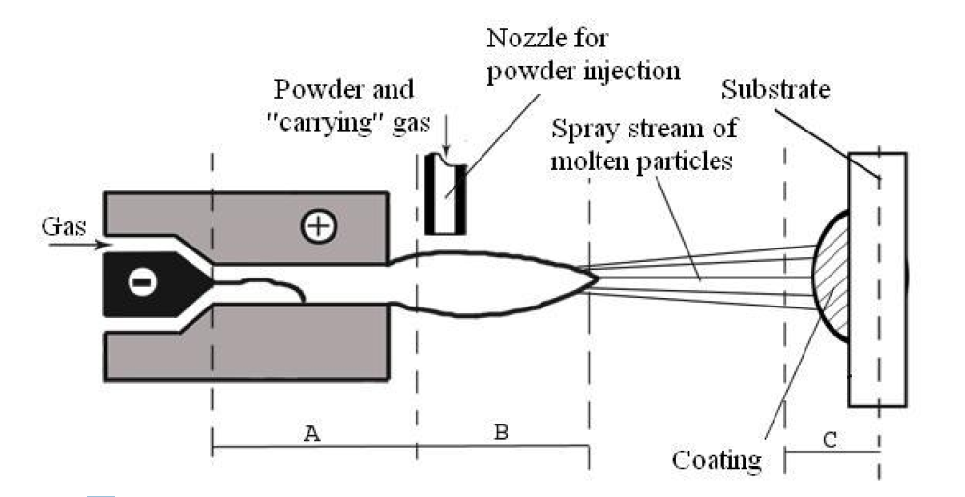

**Figure 1: Schematic diagram of plasma spray process for forming a coating**

## Process Parameter of Plasma Spray Process

Some important process parameters and their roles are listed below;

* Power supply
* Gas system
* Carrier gas
* Powder system
* Mass flow rate of powder
* Powder related variables
* Stand-off distance (TBD)
* Angle of powder injection

### Power supply

The power is supply in to the plasma gas, which in turn heats the plasma stream. Arc power determines the mass flow rate of a given powder that can be effectively melted by the arc. Deposition efficiency improves to a certain extent with an increase in arc power, since it is associated with an enhanced particle melting. However, increasing power beyond a certain limit may not cause a significant improvement. On the contrary, once a complete particle melting is achieved, a higher gas temperature may prove to be harmful. In the case of steel, at some point vaporization may take place lowering the deposition efficiency [9].

### Gas System

Primarily, the principal properties of a gas are dependent on the movement of its individual molecules. The velocity of molecules will increase due to the temperature of the plasma gas increases. Diatomic gas molecules disintegrate into atoms due to mutual collision when the velocity of the particles reaches at high level. This process taking place in plasma arc is called dissociation. When higher levels of energy are supplied, that not only molecules are dissociated but the process of ionization also occur where the electrons beforced out from the envelop of atoms [13]. 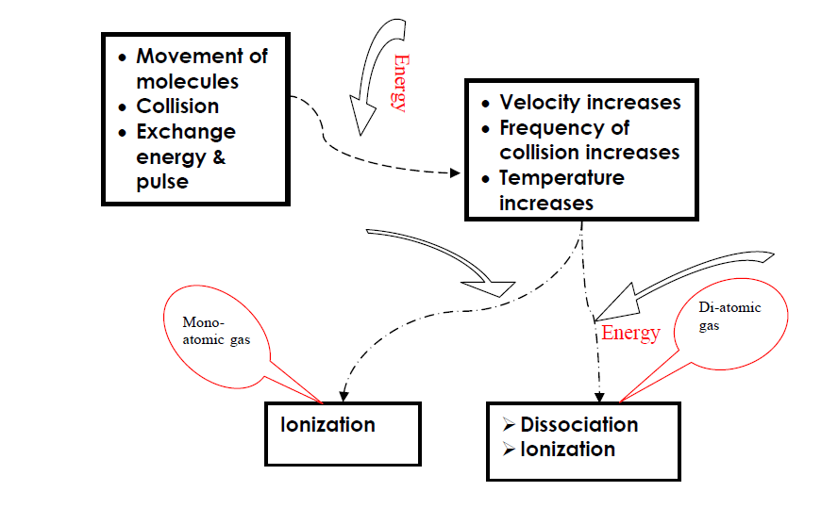

Figure 1: Theory of Gas Mechanics [9]

Generally, the gases such as argon, helium, hydrogen, and nitrogen are brought to the plasma state. The forming of plasma gases is categorized into two basic groups which are monatomic and diatomic gases. Helium and argon belong to the first group, while hydrogen and nitrogen belong to the other. The physical and chemical characteristics of different gases are shown in Table 2.1:

**Table** **2-1: Plasma forming gases properties [13]**.

|  |  |  |  |  |
| --- | --- | --- | --- | --- |
| Properties | Argon | Helium | Nitrogen | Hydrogen |
| Relative molar weight | 39.94 | 4.00 | 28.02 | 2.02 |
| Specific heat capacity *cp* at 20 °C  (kJkg-1K-1) | 0.520 | 5.19 | 1.04 | 14.32 |
| Thermal conductivity coefficient  at 25 °C (Wm-1K-1) | 0.016 | 0.14 | 0.024 | 0.17 |
| Temperature (K) | 14 000 | 20 000 | 7 300 | 5 100 |

### Carrier gas

A carrier gas usually used is the primary gas itself because their characteristic as inert and reactive gas. When the flow rate is very low, it cannot convey the powder effectively to the plasma jet and when flow rate is very high then the powders might escape the hottest region of the jet (as shown in Fig 2.6) [8]. There is an optimum flow rate for each powder at which the fraction of un-melted powder is minimum and hence the deposition efficiency is maximum. The flow rate of the career gas is an important factor for plasma spray.

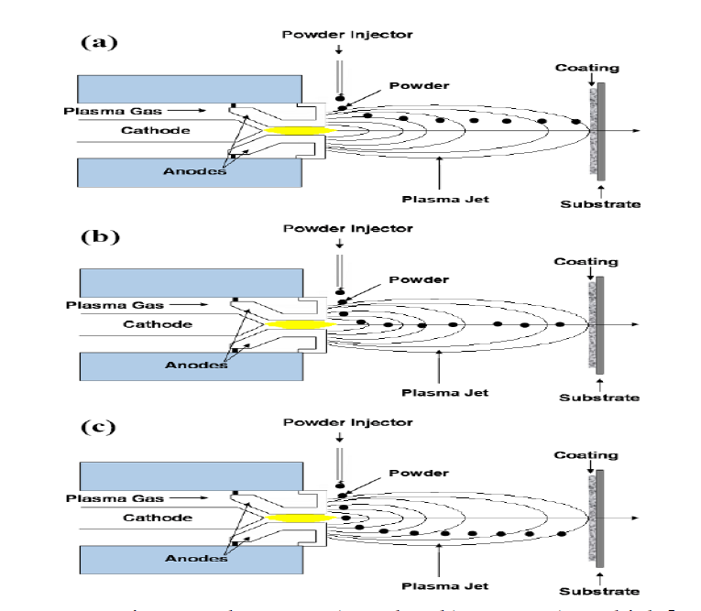

Figure 2:Carrier Gas Flow Rate a) too low b) correct c) too high [9].

### Powder System

An ideal mass flow rate for each powder has to be determined. Spraying with a very high mass flow rate possibly will give to an incomplete melting resulting in a high amount of porosity in the coating. The un-melted powders may bounce off from the substrate surface as well keeping the deposition efficiency. On the other hand, spraying with low mass flow rate possession all other circumstances constant consequences in underutilization and slow coating build up [8].

Besides that, the coating formation depends on the type variable of powder. These variables are powder shape, size, phase composition, size distribution, and processing history etc. They create a set of very important parameters. For illustration, if the powder size is a very large particle may not melt substantially and therefore will not deposit while too small it might get vaporized. The shape of the powder is also quite important. A spherical powder will not have the same characteristics as the angular ones, and hence both could not be sprayed using the same set of parameters [8].

### Stand-Off Distance

These parameter is the distance between the tip of the gun and the surface of substrate. Freezing of the melted particles before they reach the target due to long distance, whereas a short standoff distance possibly will not provide enough time for the particles in trip to melt. Kobayasi Akira has studied in detailed the relationship between the coating properties and spray parameters in spraying alpha alumina [10].

The thickness of the coating decreases with increases in standoff resulting in increasing of the porosity. The usual alpha-phase to gamma-phase transformation during plasma spraying of alumina has also been constrained by increasing this distance. A larger fraction of the un-melted particles go in the coating owing to an increase in torch to base distance.

### Angle of Powder Injection

Powders can be shoot up into the plasma jet perpendicularly, obliquely or coaxially. The residence time for the powders in the plasma jet will differ with the angle of injection for a given carrier gas flow rate. The residence time in turn will influence the degree of melting of a given powder. For illustration, oblique injection may be useful to melt high melting point materials a long residence time. The angle of injection is found to effective the adhesive and cohesive strength of the coatings as well [1].

## Mechanism of Coating Formation in Plasma Spraying Process

Plasma spray is formed by the impact of a particles stream from nozzle striking the substrate surface. The main factors which influenced by the structure of a coating are the temperature, velocity, and size distribution of the incident particles. Perfectly all the surface striking particles would be completely molten. Unmolten particles may bounce off reducing the deposition efficiency and partly melted particles are unified within the deposit modifying its microstructure and properties [12]. H.W. Ng, Z. Gan said that coatings are formed by successive layers of molten droplets which flatten and solidify on impact to give lamellar microstructure. When a liquid droplet strikes the surface at low velocity, it flattens to a disc (shown in Fig 2.9) [11] which then come to the steadiness shape of spherical cap to form a cone and the blowouts again to the final steadiness shape determined by the static surface tension forces (shown in Fig 2.10). Thin sheet of liquid becomes unstable at high impact velocities and splits at the edge into many small droplets and splashing happens. Then cooling rate rapidly increases by conduction from molten particle to surface of the substrate.

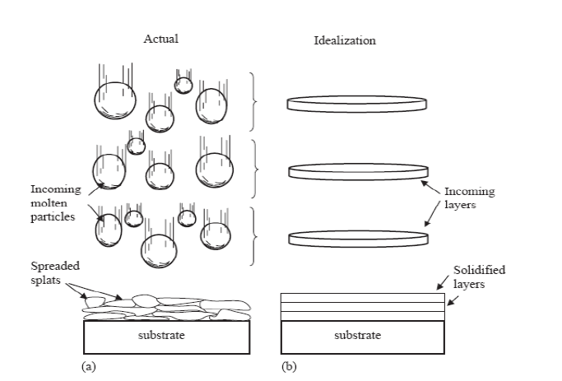

Figure 3:Schematic of the (a) physical plasma spray process and (b) its idealization for modelling [11]

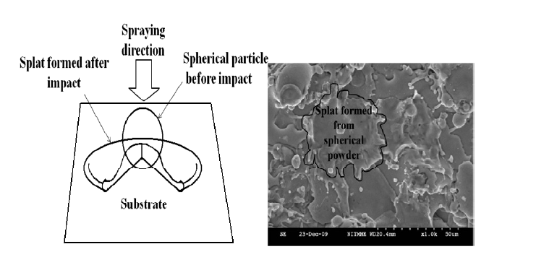

Figure 4:Splat formations after the impact of the spherical powder during spraying [11]

## Cooling System

None of the existing electrode material can survive a long time in contact with the plasma without intensive cooling. Therefore, both anode and cathode must be cooled by an appreciate cooling agent. Deionized water in a closed circulating loop is typically used due to its superior properties as cooling agent and relatively low costs. Major requirements to the cooling water are the following:

* It should not contain air bubbles, which could cause a local loss of cooling inside the torch(hotspot) and rapid damage of the electrode, respectively
* Sufficiently high purity water to avoid an intense deposition of salts (including lime) inside the torch cooling system and related decrease of cooling efficiency
* Low inlet temperature. These requirements allow to keep the water outlet temperature at the acceptable. Usually the temperature different between inlet and outlet varies between 15-30K, depending on plasma operating power and water flow rate. In extreme conditions condition, it could reach 40-45K. Higher temperature increase inside the reactor usually is an indicator of faulty operation of the cooling system or of improper design

The typical coating cell cooling system consists of:

* The torch cooling system, whose function is to assure the removal of heat from the anode and cathode
* Water supply pipes and water pump, which develop pressure required to pump the necessary amount of water through the entire hydraulic network
* Water settling/heat exchanger with a tank, where the water is freed from air bubbles and chemically treated in order to remove the dissolve oxygen, organic compound and salts. The latter measure help to reduce oxidation of the copper electrode surfaces and to prevent contamination of the inner surfaces, which would decrease the thermal conductivity and would lead to the final clogging of the cooling system (Thermal spraying for power generation)

### Parallel Water Cooling Structure

Commonly a series of cooling water flows is used in the structure which water flows from one component to adjacent one in series thus the temperature of water become higher and higher. Thus, the erosion of the electrodes increased. So, a parallel water cooling structure was designed as shown in Figure 2 which the cooling water was flows for each subcomponent from one side to another side at a same time in which to ensure all the component evenly cooled (Xiuquan Cao Deping Yu,2016) [5].

Furthermore, it can increase the temperature of the arc center because it is related to the temperature of the inner wall of the anode by the Elenbaas–Heller equation shown in equation below:

Where; =the temperature of the arc center,

= the temperature of the inner wall of the anode,

E = electric field intensity,

the radius of the arc channel,

= the radial heat conduction coefficient

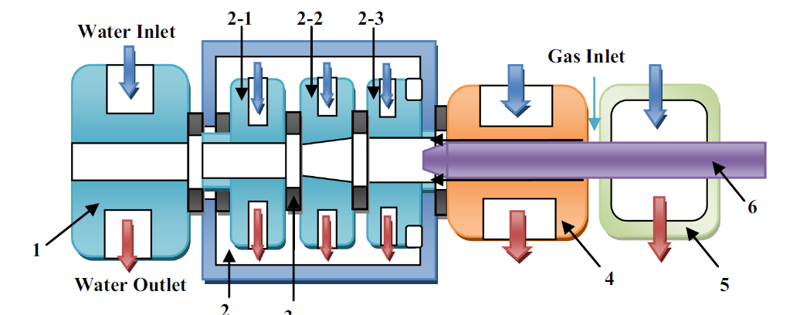

Figure 5: Parallel Water Cooling Structure

If the fringe of the arc is cooled, i.e. k is close to 0, To will rise. In fact, a decrease in the wall temperature results in an increase in the heat flux to wall and thus a decrease in thermal efficiency and enthalpy input in the plasma jet. However, the decrease in the wall temperature also results in an increase of the thickness of the cold layer, which means that the arc is more constricted. Thus, the highest temperature of the arc would increase. For the proposed plasma torch, the parallel water cooling structure keeps that each component has a low temperature, leading to a higher outlet temperature of the plasma jet [5].

### Water Stabilized Torch

In a water stabilized torch it is possible to create plasma with an extremely high plasma enthalpy (150-300 MJ/kg) and velocity. In this type of torch, a liquid vortex is created in a cylindrical chamber by a tangential injection of water. The electric arc is stabilized by the water wall and the plasma is produced by the evaporation water of the vortex. The anode is cylindrical and water cooled to reduce erosion [15].

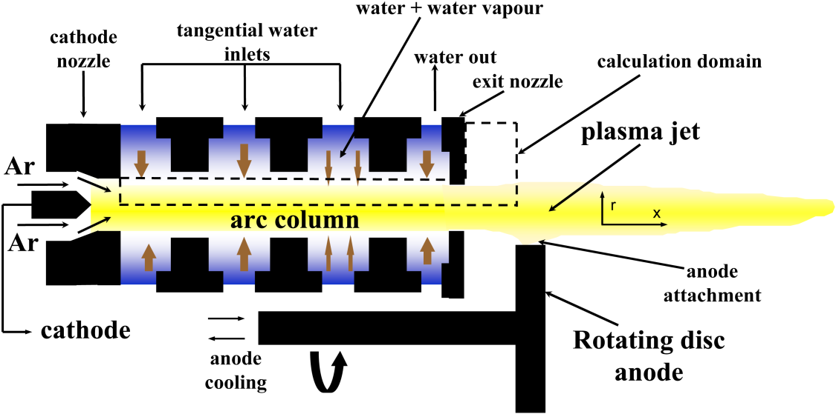

Figure *6*: Water Stabilized *T*orch

### Hybrid Water-Gas Stabilized Torch

This is the type of torch used in the reactor for waste treatment. The arc column is divided into two parts, an upstream gas stabilized part and a downstream water stabilized part.

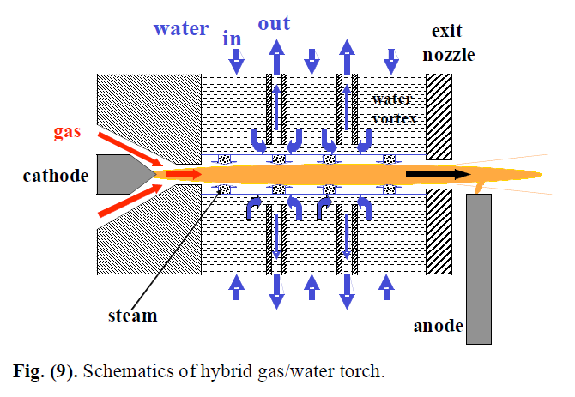

*Figure 7: Hybrid Water-Gas Stabilized Torch*

The plasma jet properties such as velocity, enthalpy, mass flow rate, and others can be varied in significantly wider range by changing the gas flow rate compared to pure gas- or liquid-stabilized torches. It is possible to control the plasma velocity and momentum flux in the plasma jet by changing the argon flow rate almost independently of the plasma temperature, which is controlled by the arc current. This type of torch has some distinct characteristics: [15]

* The plasma has a very high enthalpy (more than 200MJkg-1), till 30 times higher as thermal plasmas created by other torches. By equal torch power the amount of plasma gas is lower than by conventional gas torches. This results in the higher enthalpy.
* High plasma temperature (more than 15000 K): A plasma temperature that is three times higher than by other torches can be reached.
* High velocity and thus a high turbulence.

###### METHODOLOGY

###### RESULTS AND DISSCUSSIONS

###### CONCLUSION

REFRENCES